Properties of the game
When you click on Properties in the Project Manager, a window is opened where you can change some global parameters for the game. Some will be used when the game is exported as a Windows/macOS/Linux app or an Android/iOS mobile game.
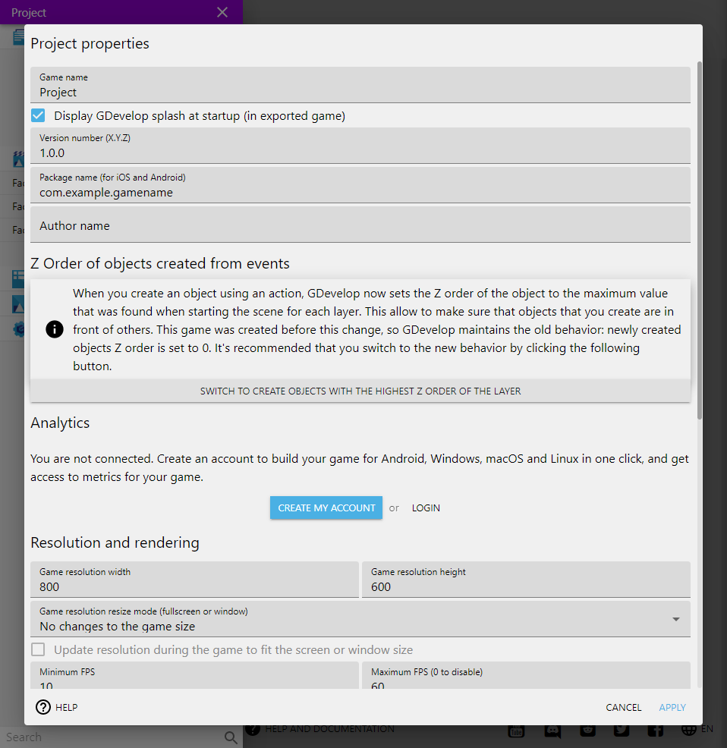
it is in these properties, you can find:
- Game name : The name given to your game (will be the application name),
- Game's window width : The width of the game area, and so the window (on desktop).
- Game's window height : The height of the game area, and so the window (on desktop)
- Author name : Enter your name here or you company. Can be used for applications generated on Windows, macOS or Linux.
- Version number : Each time you're releasing a new version, you should increment this version number. This is mandatory to do so on some stores, like the Google Play Store or the App Store.
- Project file type : By default, your game is saved in a single file. You can also choose to save it as a multiple files: each scene, external layout, external events will be saved in a different file. This is perfect for working on a large game in a team and sharing your game in a version control system like Git or Mercurial.
- Minimum FPS : By default 20, the minimum number of frames per second. If the game can't be run over this framerate (because of a lag, or a device/computer not powerful enough), the game will be slowed down.
- Maximum FPS : By default 60, the maximum number of frames per second.
- Package name (for iOS and Android) : read about this here.
- Device orientation (for iOS and Android) : Choose if the game should run in portrait or landscape mode on mobiles.
- Scale mode (also called “Sampling”) : when set to linear, textures will be antialiased, meaning that they can be a bit blurry but render well even if resized. Set to “nearest” to keep pixels visible, without any interpolation. This is perfect for pixel perfect games.
- Fullscreen / game size mode : Adjust the rendering area to the game window. If you run on a web browser or a mobile, you can choose to extend the width of the game, the height, or not to extend anything (in which case, the game will run with black margins)
- AdMob application ID (for iOS and Android) : Read more about AdMob.
- Display GDevelop splash at startup (in exported game) : Display a GDevelop splashscreen at the beginning of the game, while loading the assets. To uncheck this, please get a subscription to help supporting GDevelop.

